Normalization

 Normalization is the process of dividing a [database](http://www.webopedia.com/TERM/D/database.htm) into two or more [tables](http://www.webopedia.com/TERM/T/table.htm) and defining relationships between the tables. The objective is to isolate data

1. First Normal Form (1NF) – Repeating Groups
2. Second Normal Form (2NF) – Partial Dependencies
3. Third Normal Form (3NF) – Transitive Dependencies

Consider the following table in Un-Normalized form

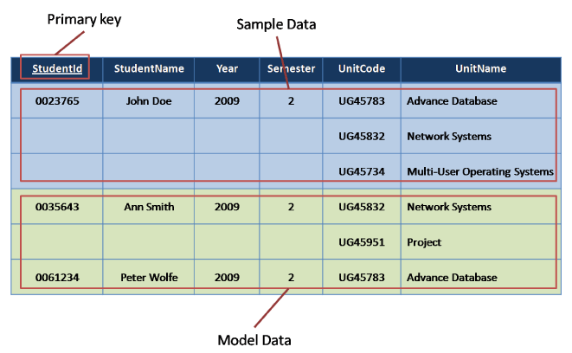

1st Normal Form:

In 1st Normal Form a table of row data can’t contain repeating data i.e. each column must have unique value. Each row must have unique identifier i.e. Primary key.

**Steps to from UNF to 1NF are:**

* Identify repeating groups of data.
* Remove the domains of the repeating groups to a new relation
* The original primary key will not now be unique so assign a new primary key to the relation using the original primary key as part of a compound or composite key.
* After followed these simple steps we have relations that looks like this:

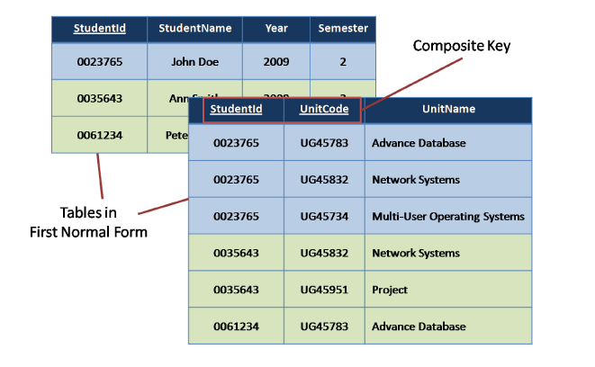

2nd Normal Form:

A table to be in 2nd Normal Form first it should be in 1st NF and there must not be any partial dependency of any column on Primary key.

But if we look at our example we can see for every UnitCode we are also storing the UnitName as follows…

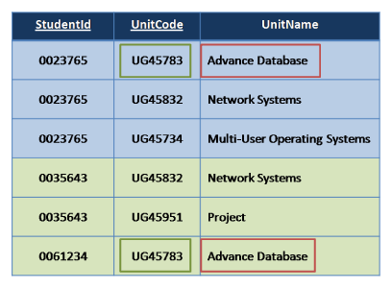

**The steps from 1st NF to 2nd NF are:**

1. Take each non-key domain in turn and check if it is only dependant on part of the key or not

2. If yes ,

a. Remove the non-key domain along with a copy of the part of the key it is

dependent upon to a new relation.

b. Underline the copied key as the primary key of the new relation.

c. Move down the relation to each of the domains repeating steps 1 and 2 till you have covered the whole relation.

d. Once completed with all partial dependencies removed, the table is in 2nd

normal form

In our example above, UnitName is only dependant on unitCode and has no

dependency on studentId. Applying the steps above we move the unitName to a new

relation with a copy of the part of the key it is dependent upon. Our table in second

normal form would subsequently look like this:

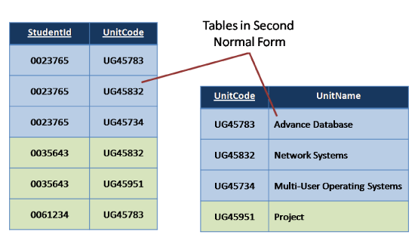

3rd Normal Form:

Third Normal Form deals with something called ‘transitive’ dependencies.

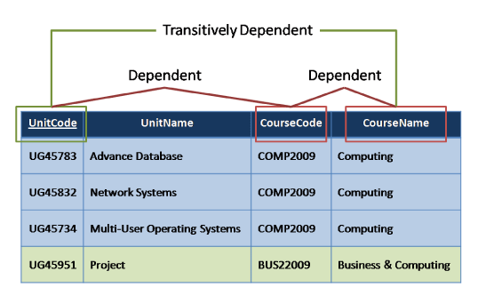

**The steps from 2NF to 3NF are:**

1. Take each non-key domain in turn and check it is more dependent on another non-key domain than the primary key.
2. If yes
   1. Move the dependent domain, together with a copy of the non-key attribute upon which it is dependent, to a new relation.
   2. Make the non-key domain, upon which it is dependent, the key in the new relation.
   3. Underline the key in this new relation as the primary key.
   4. Leave the non-key domain, upon which it was dependent, in the original relation and mark it a foreign key (*).
3. Move down the relation to each of the domains repeating steps 1 and 2 till you have covered the whole relation.
4. Once completed with all transitive dependencies removed, the table is in 3rd normal form.

In our example above, we have unitCode as our primary key, we also have a courseName that is dependent on courseCode and courseCode, dependent on unitCode. Though couseName could be dependent on unitCode it more dependent on courseCode, therefore it is transitively dependent on unitCode.

So following the steps, remove courseName with a copy of course code to another relation and make courseCode the primary key of the new relation. In the original table mark courseCode as our foreign key.

